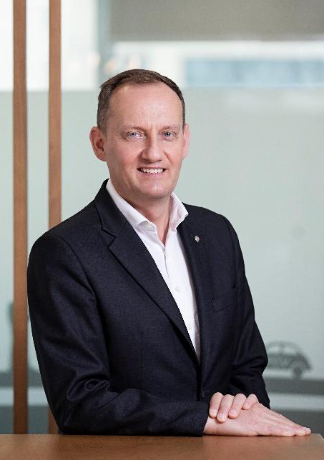
Nicolas POIROT

President & CEO
Air Liquide greater China

Nicolas Poirot was appointed as President & CEO of Air Liquide greater China in August, 2019.

Before taking this position, Mr. Poirot was the Vice President of Air Liquide South West Europe, based in Paris, since March 2016, overseeing 150 sites in France, Italy, Spain and Portugal.

From 2012 to 2016, he served as the Group Vice President of Strategic & Operations Control & Executive Committee Secretary, responsible for Group performance piloting, strategic planning, and investment.

Nicolas spent 10 years in Southeast Asia between 2002 and 2012, holding positions of increasing responsibilities, from Sales & Marketing Director in Indonesia to Southeast Asia regional role (based in Singapore) and country Manager of Vietnam, after working in Engineering from 1999 to 2002. He started his journey with Air Liquide as on-site operations manager in Southern Africa in 1995.

Nicolas holds a MSc Chem Engineering degree from Ecole des Mines de Paris, and took advanced Management Programmes in London Business School and Singapore Nanyang Technological University.

Nicolas is also a French economic trade advisor (CCEF), and board advisor of CAB CEIBS, and board director in AICM (International chemical manufacturers) .

柏昊天

液化空气大中华区
总裁兼首席执行官

柏昊天于 2019 年 8 月被任命为液化空气大中华区总裁兼首席执行官。

此前，柏昊天自 2016 年 3 月起担任液化空气西南欧副总裁，常驻巴黎，负责监管法国、意大利、西班牙和葡萄牙150家工厂的业务。

2012年至2016年，他但任集团战略与运营控制副总裁兼执行委员会秘书，负责集团绩效指引、战略规划和投资。

2002 年至 2012 年，柏昊天在东南亚工作10年，从液化空气印度尼西亚销售和营销总监、东南亚区域管理岗位（常驻新加坡）、到液化空气越南总经理。

1999 年至 2002 年，他在工程部门工作。他于1995 年加入液化空气集团，在南非担任现场运行经理。

柏昊天拥有巴黎高等矿业学校化学工程硕士学位，并曾在伦敦商学院和新加坡南洋理工大学研读高级管理课程。

柏昊天还是法国经济贸易顾问(CCEF)、中欧商学院顾问委员会委员、国际化学品制造商协会董事会董事。

